**NetView Insight:** The Detail column appears on the far left of the results grid in the NetView Insight Search.  The icon in this column acts as a link to NetView Insight, a feature which compiles and displays data related to that particular customer.

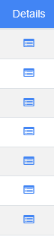

Click on the icon in a customer’s entry to view their NetView Insight page. You do not have to select the customer entry in order to open NetView Insight.   **NOTE:** You can also create a NetView Insight icon on your desktop and access the program from there.

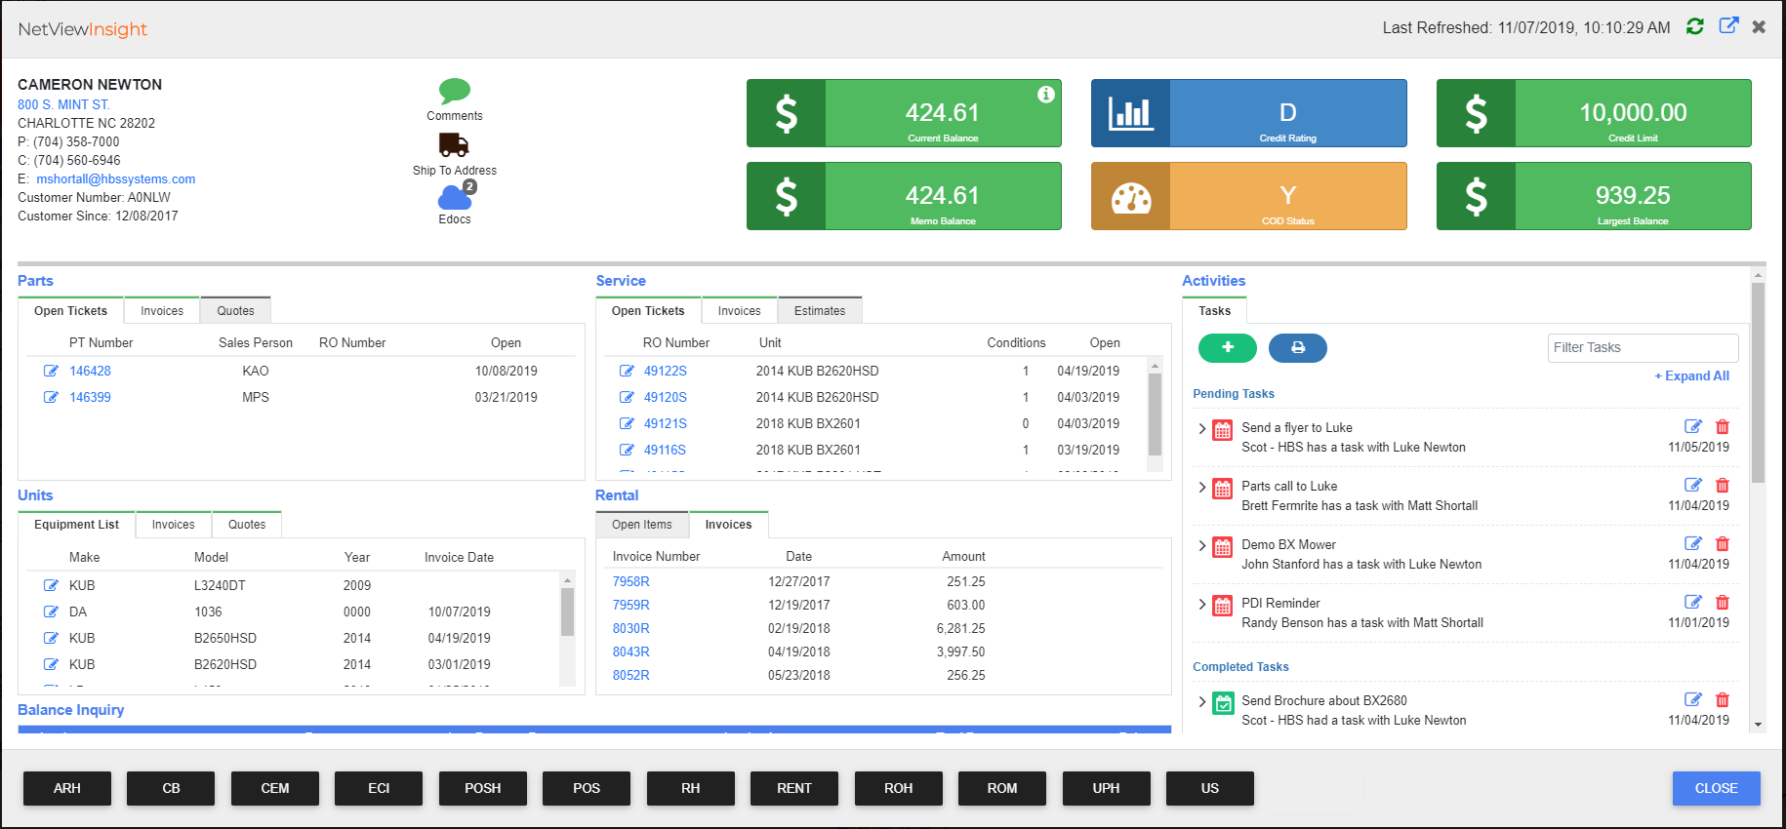

**Header:** The NetView Insight window header displays the following information:

Basic Customer Info: The customer’s basic information will appear in the upper left corner of the header.  This includes:

* Customer name
* Customer address (links to Google Maps so you can look up directions to the address)
* Customer phone number(s)
* Customer email (automatically opens a blank email to that customer provided you have an email program set up)
* Customer number (assigned by business)
* “Customer Since” (displays the date of the customer’s first interaction with you or your business)

Customer Comments: This feature is represented by a speech bubble icon. When it is colored green, you may click it to view all comments made on this customer.

Ship To Address: This feature is represented by a shipping truck icon.  When it is colored black (instead of greyed out), you may click it to view the customer's shipping address(es).

eDocs: This feature is represented by a cloud icon.  When it is colored blue and shows a number next to it (as in the image above), that means the customer has eDocs attached to their Insight page, with the number representing the number of files attached.  Click on the icon to view the files in the following window:

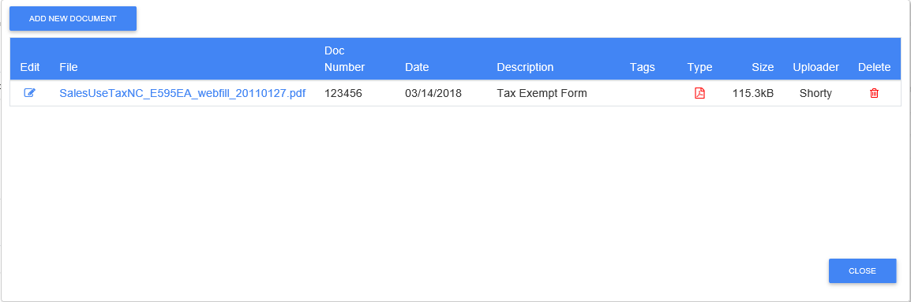

To add a new document to the customer's Insight page, click the **Add New Document** button.  Another window will open:

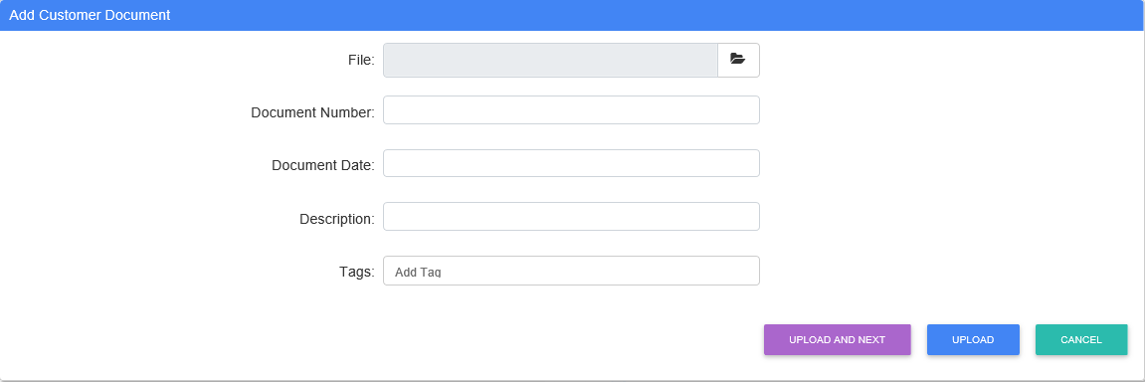

Locate the desired file using the **Browse** feature in the File field.  Fill in the remaining required fields, along with any other information you desire, and click **Upload** to add the file.  The document will then appear in the eDocs listing for the customer.

**NOTE:** If you want to add more than one file at once, use the **Upload and Next** button to upload your initial file. The file will upload and the window will automatically clear all the fields so you can immediately start uploading another file without having to re-open the window.

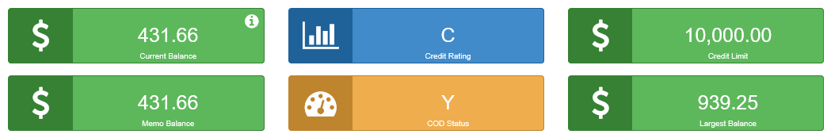

Current Balance: The customer’s current balance is displayed in a green box with a white “$” on the left. Click on the white “i” icon in the upper right corner of the box to view a a chart of the customer’s balance from current to 90+ day periods:

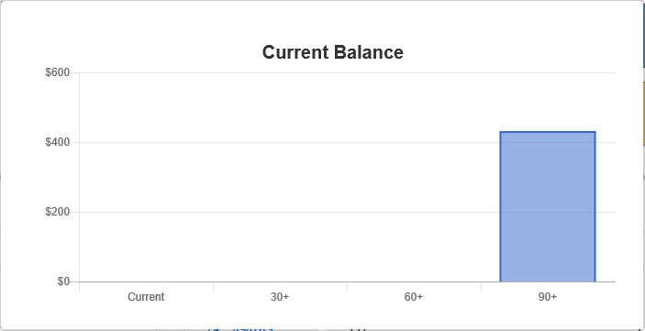

To dismiss the chart, click on the Insight page outside of it, and it will disappear.

Memo Balance: The customer’s memo balance is displayed in a green box with a white “$” on the left, located just below the Current Balance box.

Credit Rating: The customer’s credit rating is displayed in a blue box with 3 uneven white bars on the left.

COD Status: The customer’s COD status is displayed in an orange box with a white dial on the left.

* (Y)=Customer on COD
* (N)=Customer not on COD

Credit Limit: The customer’s credit limit is displayed in a green box with a white “$” on the left, located to the right of the Credit Rating box.

Largest Balance: The customer’s largest balance is displayed in a green box with a white “$” on the left, located just below the Credit Limit box.

**Parts:** The Parts section displays information related to any parts the customer has purchased from the business.  It is divided into 3 tabs.  **NOTE:** if one of the tabs is greyed out, then there are no records in that tab.

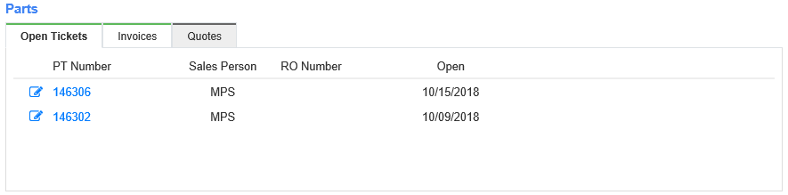

Open Tickets: The Open Tickets tab displays the records of the customer’s open Parts tickets.  Each record shows the part number, the salesperson who sold that part to the customer, the repair order (RO) number, and the date the ticket was opened.

* **To view an open ticket**, click on the blue part number.  The ticket will then display in a new window.
  + You can also click the blue icon on the far left to view the ticket in Point-of-Sale (POS).
  + **NOTE:** If the part number is not blue, then there is no ticket to view.
* **To edit the open ticket**, click the blue icon on the far left of the row.  The ticket will open in POS in a new window, where you can make the desired changes and save the ticket.

Invoices: The Invoices tab displays the records of the invoices for Parts purchases made by the customer.  Each record shows the invoice number, the date it was opened, the salesperson who opened the invoice, and the amount. **To view an invoice**, click the blue invoice number.  The invoice will then display in a new window. **NOTE:** If the invoice number is not blue, then there is no invoice to view.

Quotes: The Quotes tab displays the records of quotes associated with the customer.  Each record shows the part number, the name of the sales person who made the quote, the RO number, and the date the record was opened. **To view and edit the quote**, click the blue icon on the far left.  The record will open in its root program in a new window, where you can make your desired changes.

**Service:** The Service section displays information related to Service repairs ordered by the customer.  It is divided into 3 tabs. **NOTE:** If one of the tabs is greyed out, then there are no records in that tab.

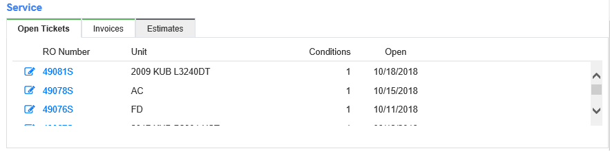

Open Tickets: The Open Tickets tab displays the records of the customer’s open Service tickets.  Each record shows the RO number, the unit serviced, condition number, and the date the ticket was opened on.

* **To view an open ticket**, click on the blue RO number.  The ticket will display in a new window.
  + You can also click the blue icon on the far left.  The ticket will open through its root program in a new window.
  + **NOTE:** If the RO number is not blue, then there is no open ticket to view.
* **To edit an open ticket**, click the blue icon on the far left.  The record will open in Repair Order Maintenance (ROM) in a new window, where you can make your desired changes.

Invoices: The Invoices tab displays the records of the customer’s Service invoices.  Each record shows the invoice number, the RO number, the date of the invoice, and the amount.  **To view an invoice**, click the blue invoice number of the desired entry.  The invoice will then display in a new window. **NOTE:** If the invoice number is not blue, then there is no invoice to view.

Estimates: The Estimates tab displays all Service estimates given to this customer. Each record shows the estimate number, the unit the estimate was created for, the date the estimate was opened, and a description of the work.

* **To view the estimate**, click the blue RO number.  The estimate will then display in a new window.
  + You can also click the blue icon on the far left.  The estimate will then open through its root program in a new window.
  + **NOTE:** If the RO number is not blue, then there is no estimate to view.
* **To edit the estimate**, click the blue icon on the far left.  The estimate will then open through its root program in a new window, where you can make your desired changes.

**Units:** The Units section displays information for Unit sales made to the customer.  It is divided into 3 tabs. **NOTE:** if one of the tabs is greyed out, then there are no records in that tab.

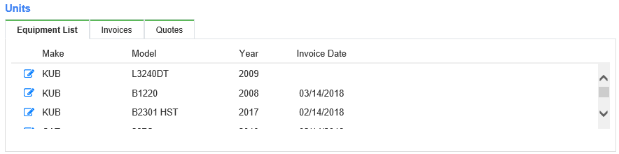

Equipment List: This tab displays the records of all equipment owned by the customer.  Each record contains the make, model, and year of the product, as well as possibly the date of the sales invoice. **To view and edit the equipment record**, click the blue icon on the far left column of the desired record row.  The record will open through its root program in a new window, where you can make changes if desired.

Invoices: The Invoices tab displays the records of the invoices for Units purchases made by the customer.  Each record shows the invoice number, the date it was opened, the salesperson who opened the invoice, a description of the invoice, and the amount.  **To open an invoice**, click the blue invoice number of the desired entry.  The invoice will display in a new window. **NOTE:** If the invoice number is not blue, then there is no invoice to view.

Quotes: The Quotes tab displays the records of Unit quotes associated with the customer.  Each record shows the invoice number, date it was opened, the name of the salesperson who made the quote, a description of the quote, and the amount of the quote.

* **To view the quote**, click the blue invoice number.  The quote will then display in a new window.
  + You can also click the blue icon on the far left.  The quote will then open in Unit Sale (US) in a new window.
  + **NOTE:** If the RO number is not blue, then there is no quote to view.
* **To edit the quote**, click the blue icon on the far left.  The quote will then open in US in a new window, where you can make your desired changes.

**Rental:** The Rental section displays information related to the customer’s equipment rentals.  It consists of 2 tabs. **NOTE:** If one of the tabs is greyed out, then there are no records in that tab.

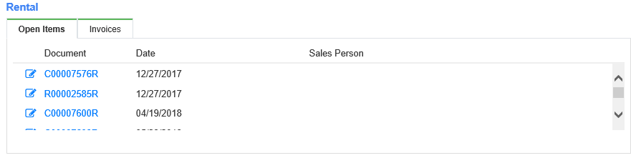

Open Items: The Open Items tab displays the records of items still being rented out by this customer.  Each record shows the equipment’s document number, the date the equipment was rented, and the salesperson who rented the equipment out.

* **To view the rental document**, click the blue document number of the desired entry.  The document will then display in a new window. **NOTE:** If the document number is not blue, then there is no document to view.
* **To view and edit the rental contract**, click the blue icon on the far left.  NetView Rental (RENT) will then open in a new tab and pull up the contract, which you can edit as desired.

Invoices: The Invoices tab displays the customer’s Rental invoices.  Each record shows the invoice number, the invoice date, and the amount.  **To view an invoice**, click the blue invoice number of the desired entry.  The invoice will then display in a new window. **NOTE:** If the invoice number is not blue, then there is no invoice to view.

**Balance Inquiry:** The Balance Inquiry section displays the details of the customer’s balance.

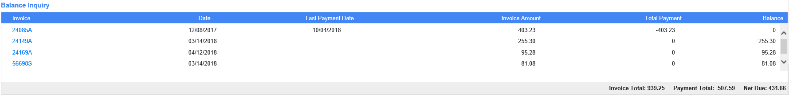

Each record represents an invoice that contributed to the calculation of the customer balance, and contains the following information:

* Invoice number
* Invoice date
* Last payment date
* Invoice amount
* Total payment
* Invoice Balance

The lower right-hand corner of the section shows the following totals for the listed invoices:

* Invoice Total (total amount of invoices)
* Payment Total (total amount of payments)
* Net Due (balance remaining for all invoices after payments)

**To view any of the invoices**, click the blue invoice number of the desired entry.  The invoice will then display in a new window. **NOTE:** If the invoice number is not blue, then there is no invoice to view.

**Customer Statements:** The Customer Statements section displays a list of customer statements by date and description.

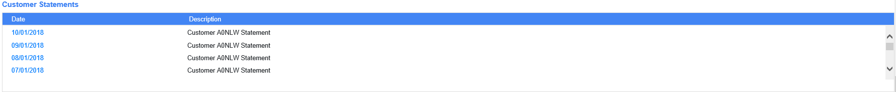

**To view a customer statement**, click on the date, which should be blue.  The statement will then appear in a new window. If the date is not blue, then there is no statement to view. **NOTE:** If the header is greyed out, then there are no records in that data set.

**Touch Report:** The Touch Report section records all changes made in Desktop relating to the customer’s information.

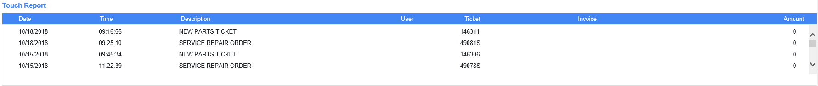

Each record shows:

* Date and time of change
* Description of what file/record was created or altered
* User who made the change (if available)
* Ticket number (if relevant)
* Invoice number (if relevant)
* Amount (if relevant)

**Activities:** The Activities section relates to Desktop user activity involving the customer.

Tasks: The Tasks section lists all Tasks (user assignments) involving this particular customer. **NOTE:** This tab functions like the **Tasks ActiveTile**, but for a specific customer instead of a specific user.

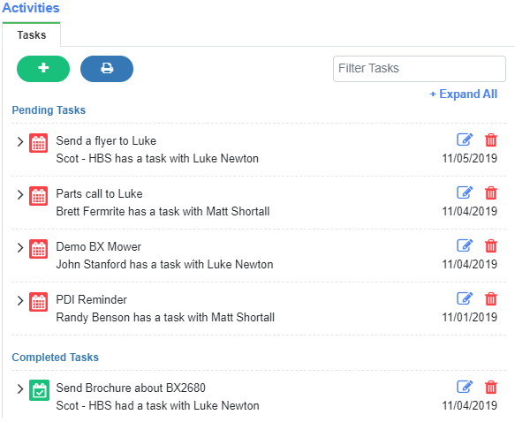

The Task List is divided into two sections: **Pending Tasks**, which shows uncompleted Tasks, and **Completed Tasks**, which shows completed Tasks. Each item on these lists will have the following information immediately visible:

* Status icon
* Task Subject
* User assigned to Task
* Customer or Customer Contact (if applicable)
* Task Due Date

To view the Task’s expanded detail, click the arrow icon to the left of the Task entry.

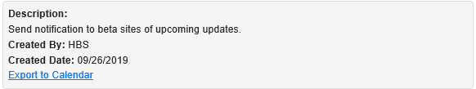

The expanded detail includes:

* Task Description
* User who created the Task
* Task Creation Date

You will also be able to export the Task to an outside calendar program by clicking the **Export to Calendar** link.

Click the arrow again to hide detail. If you want to expand all Task entries, click **Expand All** at the top of the list. It will change to **Hide All**, which you can then click to hide all the expanded detail again.

**Status Icon:** Each Task bears a color-coded Status icon, which changes when the Task’s status changes.

* **Pending:** This  status means the Task has not been completed, but is also not yet past its due date. This is the initial status for each Task when it’s created.
* **Overdue:** This  status means the Task has not been completed and is past its due date.
* **Completed:** This  status means the Task is done.

You can also use the icon itself to change the Task’s status:

* Click on a Pending or Overdue Task’s Status icon to change the status to Completed.
* Click on a Completed Task’s Status icon to revert it back to its previous status of Pending or Overdue.

**NOTE:** You can also change a Task’s status using the **Edit** function, provided you either **created** the Task to begin with or are a **system administrator** (**see below for further details**).

**Filter Tasks:** If you only want to see Tasks with specific information, enter that data in this field, located in the top right-hand corner of the tab. This will filter the Task List to show only entries with matching information.

**Add Task:** To add a new Task related to this customer from the Insight page, click the  button. The tab will change to show the following:

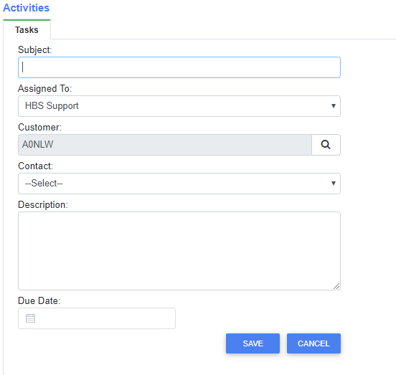

* **Subject:** Enter the Task subject here. This field is **required**.
* **Assigned To:** Select a user here to assign them the Task. This field is **required** and **defaults** to the current user (users can assign Tasks to themselves).
* **Customer:** This field will **default** to the Insight customer and **cannot** be changed.
* **Contact:** If you want to specify a contact for the customer, select an available one from this drop-down menu.
* **Description:** Enter the Task description here. This field is **required**.
* **Due Date:** Enter the Task’s due date here or select it from the calendar. This field is **required**.

Click **Save** to create the new Task, which will then appear on the Task List when the tab switches back to the list.

**Edit Task:** To edit a specific Task, click the  icon in its entry. The tab will switch to the following screen:

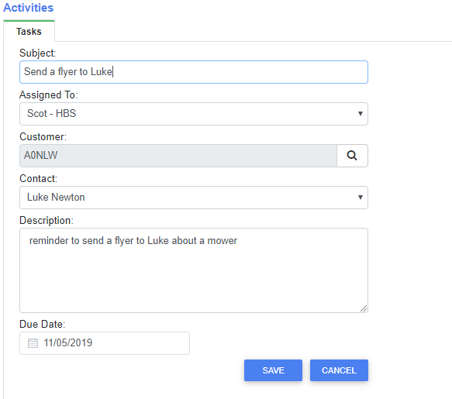

Edit the information as desired, then click **Save** to update the Task’s list entry. **NOTE:** You can only edit a Task if you **created it** or are a **system administrator**.

**Delete Task:** To delete a Task, click the  icon in its entry. You will receive a warning asking, “Are you sure you want to delete this Task?” Click **Ok** to delete the Task. **NOTE:** You can only delete a Task if you **created it** or are a **system administrator**.

**Print Tasks:** If you want to print the customer’s Task List, click the  button to generate a PDF report in a new tab (see example below).

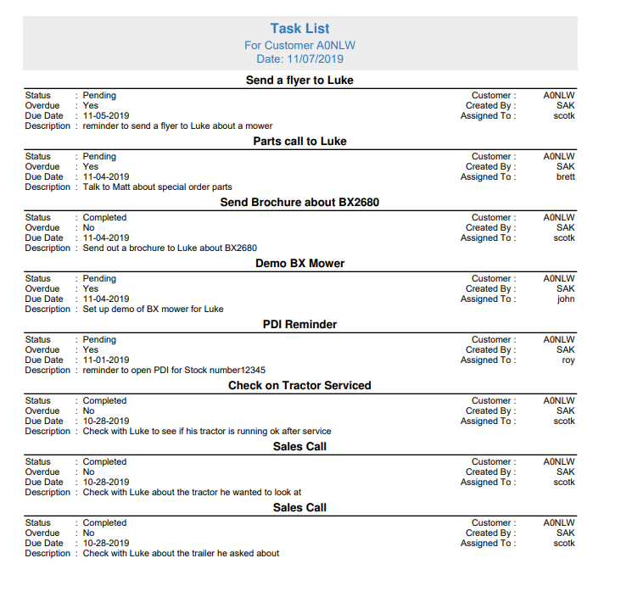



**Refresh:** To refresh NetView Insight, click the green circling arrows in the top right-hand corner of the window.  This will update the information shown in Insight to reflect any changes made since Insight was last refreshed.  The date and time the program was last refreshed appears to the left of the icon, and will update to the current date and time when you click the icon.

**New Window:** To open the Insight page in a new browser tab/window, click the blue arrow icon in the top right-hand corner.  This will allow you to use other Desktop features and applications while keeping Insight open and available for use, as well as making the display full-screen for clearer viewing.

**Close:** To close the NetView Insight window, click either the **Close** button in the lower right-hand corner of the window or the "X" icon on the top right-hand corner of the window.



**Application Shortcuts Toolbar:** The Application Shortcuts Toolbar is located at the bottom of the NetView Insight Detail page.  For more information, see “Application Shortcuts Toolbar” under “Search Customer."